

OPEN-SOURCE CODING PART 1

Tshegofatso Seopela – ST10122250 Shaun Kadzima – ST10121092 Sanele Nkabinde – ST10120790



POE PART 1

PLANNING AND DESIGN SECTION

Table of Contents

Introduction 2

Overview with application name and icon 2

Detailed list of requirements of the innovative features 2

User Interface Design 3

Mock-up for each screen including the description/purpose 4

VOOM navigation diagram 13

Project plan Gantt chart hyperlink 13

Conclusion 14

References 14

## Introduction

Right after the discovery of sliced bread, I would like to believe that the second-best invention that changed the human race’s means of living for the better through transportation is a(n) car/automobile that was first invented in 1886. A motor vehicle which is typically made from a coated metal body, an engine, glass (Fibreglass) windows, four wheels, etc. and fuelled by petrol, is used for the transportation of goods and people who need to commute for various reasons. Despite the reasons, there are multiple casualties that happen on and off the road that may need you to repair or replace certain parts or even buy a new car… This is where “VOOM” comes to play. (GAZPROM, 2022) (group Mercedes-Benz, 2022)

## Overview with application name and icon

VOOM is a motor vehicle service provider application that gives users (customers) the opportunity to out-source an enquiry regarding specific car parts or services that are in need into a pool of car dealerships where the most suitable dealership that provides the necessary parts/service enquired by the customer will be assigned to the customer to fulfil the request.

## Detailed list of requirements of the innovative features

The following innovative features are to be included in the application:

* **Search function that allows users to easily search for a specific item with a category** – the reason this feature will be implemented is to enable the users to efficiently find the product they are looking for.
* **Enable the users to upload multiple file types –** this will permit the users to upload different image file types that may be taken of the product, such as JPEG, PNG, and TIFF etc. allowing product images to be uploaded will provides users a sense that they are getting more reliable, and trustworthy images of products
* **Allow users to connect to third-party platforms** – the reason this feature is considered desirable as it will save time on the development process, and it increases the quality of the product
* **GPS-based application** *– this feature is desirable as it will allow the users to find their product in their local areas.*
* **Free service software** *–* this feature will be used as it will attract more customers/users to the application.

VOOM also has a list of requirements that the application must be able to must, such as:

Functional requirements:

* The user either being a customer, or a car dealership must be able to register themselves into a new account by creating a new username and unique password- if a user registers as a car dealership they will have to go through a verification process by submitting specific documents that authenticate them as a licenced dealership.
* The user must be able to create various category types that lists several parts they wish to purchase- a car dealership would then create different categories that list the parts or services they offer.
* Within the categories created by the user, they should be able to set targets or goals of when they would like to purchase a specific part.
* The user must be able to give a description that states an issue and that also identifies the part that they would like to acquire from a dealership- the description of a part will have to be added to it within a specific category that they will also have to be able to create.
* The user must be able to add new parts a any category of their choice.
* The user must be able to view a collection of parts that they have purchased from a dealership as well as those that are still yet to be acquired.
* The user must be able to take pictures of the issues the are experiencing with their vehicles and upload them onto VOOM to or to a respective dealership that is in progress of resolving their issue.

Non-functional requirements:

* In terms of the usability VOOM should be user friendly, users should find it fairy easy to navigate themselves through work related procedures and being able to provide easy online help.
* VOOM will have access to back up databases for recoveries in case of any disasters, revoke processes for incorrect processing as well as exception handlers for any bugs that should be detected.
* VOOM should be able to handle vast workloads with a good response time between users with little to no latency.
* As part of VOOM security measures, a user will have access to an account through authentication using credentials and the encryption of locally stored data within VOOM.

(Satzinger, Jackson& Burd, 2016)

User Interface Design:

### Mock-up for each screen including the description/purpose

When the application is opened the first page a user will see is the login page that allows registered users to log in with their credentials to access their account on the second page but if they don’t have an account there is a ‘sign up’ link provided below to get registered.

3rd

4th

If a user decides to create a new account by pressing the sign-up link, they will have the option of choosing whether to register as a customer or a service provider (car dealership) on the 3rd screen. As a customer the user will have to provide the details stated on the 4th screen to procced and have an account.

5th

4th(b)

If a user decides to create a new service provider (car dealership) account by pressing the sign-up link, on the 3rd screen, they will have to provide the details stated along with the necessary documents that verify them as a licensed car dealership on the 4th(b) and 5th screen to procced and have an account.

Main page

Once the service provider has registered and passed the verification stage, they can log in the main screen which shall appear showing them new requests from a pool of customers, a section showing all the approved Jobs cards and those that still await approval as well as the customer feedback where the dealership can be rated and commented upon.

7th

8th

When a customer clicks into a service provider’s profile they can locate where the business is situated with the help of a map (on the 7th screen). Details of the service provider are provided (on the 8th screen)

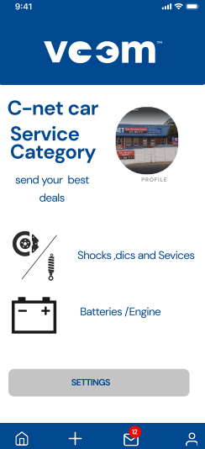

The service provider can view the new requests and messages from customers with their respective Job Card numbers by clicking the new requests button in the main screen.

The service provider will also have a created service category where services can be added and viewed by the customer when they open up the service providers profile. This screen can is accessed by the service provider from their main screen

Within the customer’s profile by clicking the plus sign they can create a new job Card describing the issue that they’re experiencing with their vehicle and which states what needs to be fixed or a part of the car that they need. Once that they’re done the customer can submit the Job Card/enquiry.

This is when the customer is contacted by the right dealership who potentially has the right service or part required by the customer. The two are then able to communicate furthermore until the customer is satisfied and the Job Card/enquiry gets fulfilled.

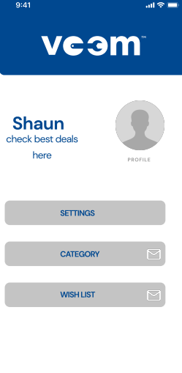 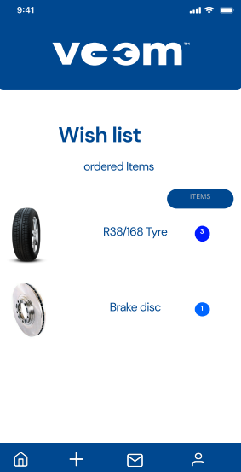

By clicking the home icon, the customer is can create various categories and add certain parts into the respective categories from the predefined category/collection found within VOOM. Same applies for the Wish-list collection, where the customer can add parts that they wish to purchase in the near future and dates can be set onto the parts in order for them to reach their goals in time.

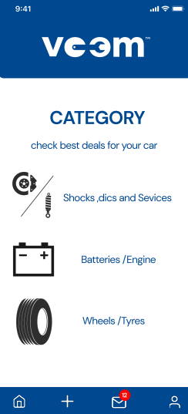

This is the predefined category found within VOOM customers can browse from, add parts from and into categories they wish to create

### VOOM navigation diagram



### Project plan Gantt chart hyperlink



## Conclusion

The planning and design section of any application is crucial but enables the designers and programmers to know exactly what they need to build and how you will build it before you start with the implementation of the application.

## References

GAZPROM. 2022. How natural gas is used as vehicle fuel. [Online]. Available at:

[How natural gas is used as vehicle fuel (gazprominfo.com)](http://www.gazprominfo.com/articles/gas-fuel/#:~:text=What%20kind%20of%20gas%20is%20used%20for%20filling,concerns%20natural%20gas%20use%20as%20a%20vehicle%20fuel.) [Accessed 02 May 2022]

Mercedes-benz. 2022. Benz Patent motor Car: The first automobile. [Online]. Available at:

[Benz Patent Motor Car: The first automobile (1885–1886) | Mercedes-Benz Group > Company > Tradition > Company History](https://group.mercedes-benz.com/company/tradition/company-history/1885-1886.html?r=dai#:~:text=The%20first%20automobile.%20On%20January%2029%2C%201886%2C%20Carl,three-wheeled%20Benz%20Patent%20Motor%20Car%2C%20model%20no.%201.) [Accessed 02 May 2022]

Satzinger, J., Jackson, R., Burd, S. 2016. Systems analysis and design in a changing world. Seventh edition. Boston: Cengage Learning.